WEBSITE SPECIFICATION DOCUMENT
- Website Specifications
Smart Relocations, a logistics company with a website developed by Host Guru, will be upgraded from the current design which is unappealing, fails to communicate a clear theme and message to the customer. Additionally, it is unapproachable in the language used therefore unable to garner customer attraction. The upgrade of the website aims to resolve these issues to meet company goals of satisfying customer expectations.
The objectives of the upgraded website are to:
- Highlight value proposition offered to the customer through trusting the company with their goods.
- Highlight limitations to extent of service provision to allow customers to be fully informed of what each service involves.
- Display contact information for further enquiries to offer customer support.
- Illustrate history of the company to give customers background information about the organisation they wish to get involved with.
- Provide platform for customers to provide feedback on services provided or gain insight into past experiences of other customers.

- The target audience of this website are manufacturers, small and medium enterprises and individuals. This target audience comprises a demography of individuals:

- With businesses located in industrial zones for transportation of finished products from workshops to final consumers, and urban areas mostly with high commercial activity.
- With a steady need for importation and exportation of goods through the service of a middleman.
- With literacy skills and completion of a minimum of basic education.
- In the age range of 24 – 65 years who have the authority to take decisions in an organization.
It is assumed users will have sufficient technical aptitude from experience with using the online platforms in their daily business operations. However, analysis on user experience will be taken and reviewed to confirm and adjust as necessary.
- The type of content design in mind for the users is one which would facilitate e-commerce activities to take place, with ease and maximum efficiency.

- Information Design & Taxonomy
Site Map

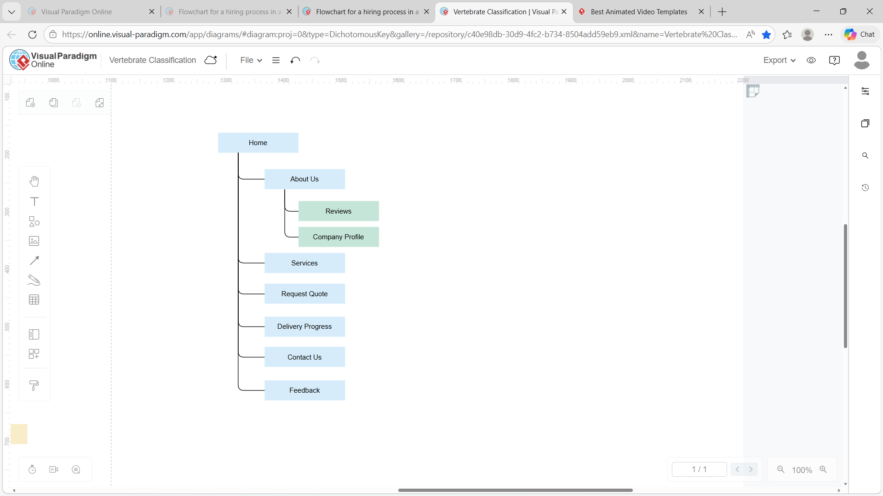

Storyboard Flowchart
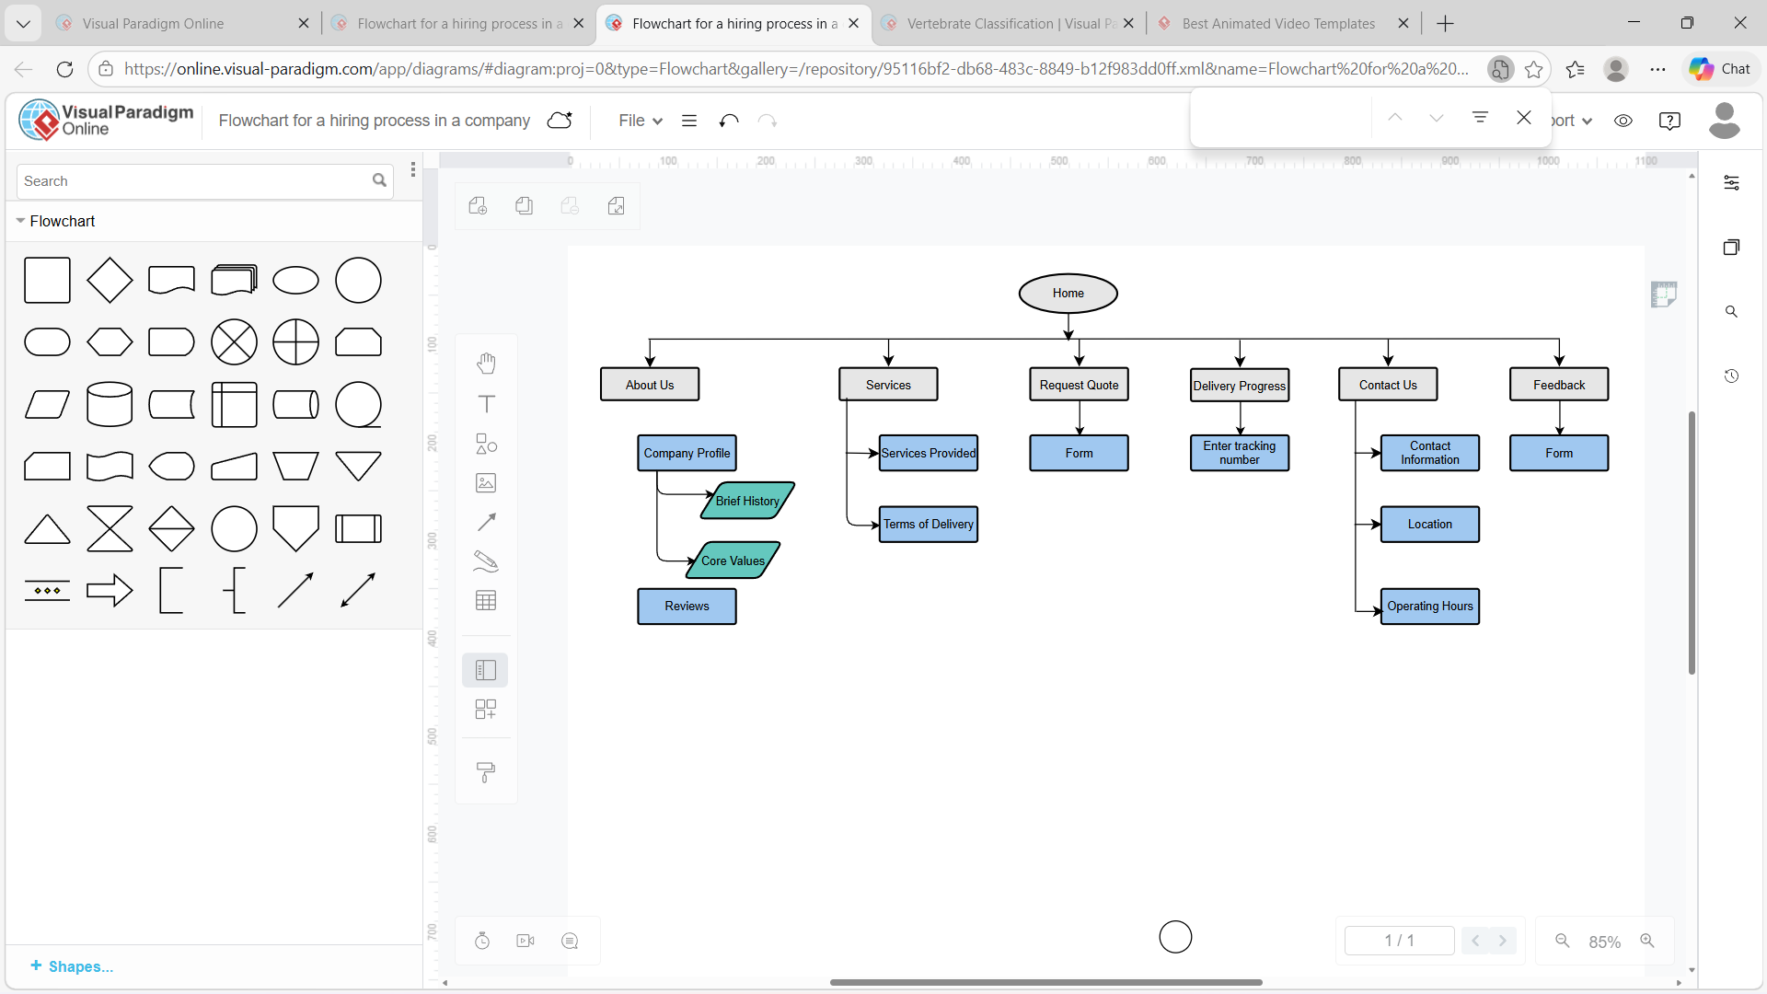

- Technical Brief
An HP 15.6inch laptop with an AMD Ryzen 5 processor will be used as the primary device for coding and testing the web pages in this project. Software resources in use will include a GIMP application tool for creation and editing of images, VS Code for coding to construct the site and Bootstrap to allow implementation of CSS throughout the code. The finished project will be hosted on GitHub Pages.

